**Network Virtualization**

In computing , network Virtualization is the process of combining hardware and software network resources and network functionality into a single , software-based administrative entity called a virtual network.

**Networking Devices**

Hardware devices that are used to connect computers, printers and other electronic devices.

**1- Modem (Modulator and Demodulator)**

Modem is a device that enables a computer to send or receive data over telephone or cable lines. Data stored in computer is digital but telephone line can transfer analog signal only so modem is used to convert Digital Wave to Analog signal.

**2- RJ-45 and NIC**

Registered Jack 45 is an 8-pin jack used by devices to physically connect to Ethernet based local Area Network. Ethernet is a technology that defines protocols for establishing a LAN.

**NIC** is a hardware component without which a computer can not be connected over a network. It is a circuit board installed in a computer that provides a dedicated network connection to computer. It allows both wired and wireless communications.

**3- Routers**

A router is a device that connects two or more networks. It manages traffic between these networks by forwarding data packets to their intended IP addresses, and allowing multiple devices to use same internet connection.

It has two interface. One side is connected to our LANs and other one to ISPs.

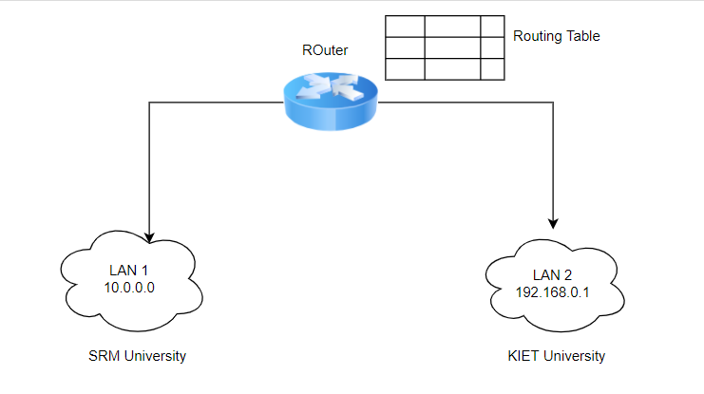

Router is used to communicate over two different networks having different IP addresses. It has memory (RAM) in it which stores routing table which has data of each and every port . When packet comes with particular IP address then it is transferred to that particular host

**4- Switch**

Switches are also networking devices which operates at data link layer. They are used within the organisation or LAN. They use MAC addresses to transfer data. They use switching techniques and maintain switch table where they store MAC addresses of devices.

Switch performs collison and error checking before sending data to particular destination

**Traditional Physical Networking Layout**

**10K physical servers == 20K NIC cards**

(If one NIC goes down then u can use another one)

**20K NIC Cards == 40K Cables**

(Lifetimes of Cable is less so keep 1 extra)

**20K NIC cards == 500 physical switches**

so all these things are heavy to manage and is more costly

**Virtualized Network**

10k servers = 10 physical server

10 physical server=20 NIC

20 NIC = 40 cables

10Physical server = 1 switch

Very less expense

Thanks to Virtualization

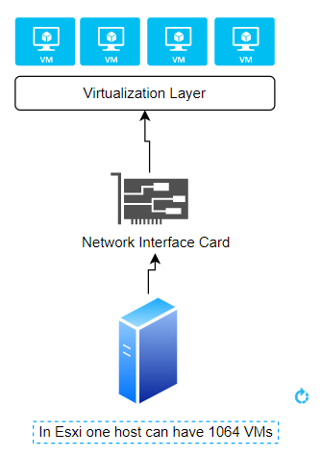

Each VM on the host has a network address with one or more virtual network cards.

Virtual switches are also there to communicate with other VMs

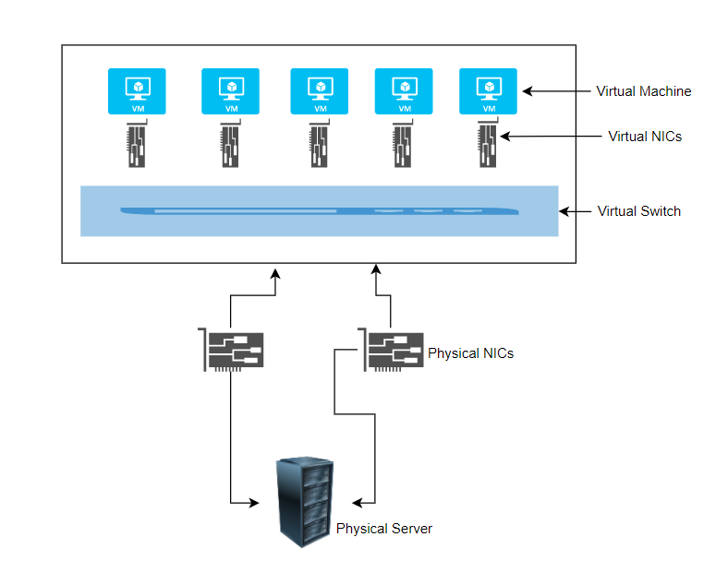

**Traffics in Virtual Network**

Virtual Machine Traffic

VMotion Traffic

Management Traffic

IP Storage Traffic